

**Faculty of engineering - Shoubra**

**Benha University**

**Research Project**

in fulfillment of the requirements of

|  |  |
| --- | --- |
| **Department** | **Engineering Mathmatics and Physics** |
| **Division** | **...........** |
| **Academic Year** | **2019-2020 Preparatory** |
| **Course name** | **computer** |
| **Coursecode** | **ECE001** |

**Title: -**

**Artificial Intelligence**

By:

|  |  |  |  |
| --- | --- | --- | --- |
|  | Name | Edu mail | B.N |
| **1** | **احمد عماد الشربيني علي** | **Ahmed195103@feng.bu.edu.eg** | **100** |

**Gethub link :** [**https://github.com/AhmedEmad2001/computer-project**](https://github.com/AhmedEmad2001/computer-project)

**Gethub puplished link :** [**https://ahmedemad2001.github.io/computer-project/**](https://ahmedemad2001.github.io/computer-project/)

**Approved by:**

|  |  |
| --- | --- |
|  | Examiners committee |
| 1 | Dr. Ahmed Bayoumi |
| 2 | Dr. Shady Elmashad |
| 3 | Dr. Abdelhamid Attaby |

**Literature Review**

Artificial Intelligence (AI) is a rapidly advancing technology, made possible by the Internet, that may soon have significant impacts on our everyday lives. AI traditionally refers to an artificial creation of human-like intelligence that can learn, reason, plan, perceive, or process natural language.

Artificial Intelligence (AI) can be categorized into four types, beginning with the task-specific intelligent systems in wide use today and progressing to sentient systems, which do not yet exist.

* Type 1: Reactive machines. These AI systems have no memory and are task specific. An example is Deep Blue, the IBM chess program that beat Garry Kasparov in the 1990s. Deep Blue can identify pieces on the chessboard and make predictions, but because it has no memory, it cannot use past experiences to inform future ones.
* Type 2: Limited memory. These AI systems have memory, so they can use past experiences to inform future decisions. Some of the decision-making functions in self-driving cars are designed this way.
* Type 3: Theory of mind. Theory of mind is a psychology term. When applied to AI, it means that the system would have the social intelligence to understand emotions.
* Type 4: Self-awareness. In this category, AI systems have a sense of self, which gives them consciousness. Machines with self-awareness understand their own current state. This type of AI does not yet exist.

Current Uses of Artificial Intelligence (AI):

artificial intelligence already has many uses today, for example:

* Email filtering: Email services use artificial intelligence to filter incoming emails. Users can train their spam filters by marking emails as “spam”.
* Personalization: Online services use artificial intelligence to personalize your experience. Services, like Amazon or Netflix, “learn” from your previous purchases and the purchases of other users in order to recommend relevant content for you.
* Fraud detection: Banks use artificial intelligence to determine if there is strange activity on your account. Unexpected activity, such as foreign transactions, could be flagged by the algorithm.
* Speech recognition: Applications use artificial intelligence to optimize speech recognition functions. Examples include intelligent personal assistants, e.g. Amazon’s “Alexa” or Apple’s “Siri”.

Artificial Intelligence Importance :

* AI automates repetitive learning and discovery through data. But AI is different from hardware-driven, robotic automation. Instead of automating manual tasks, AI performs frequent, computerized tasks reliably and without fatigue.
* AI adds intelligence to existing products. In most cases, AI will not be sold as an individual application.
* AI adapts through progressive learning algorithms to let the data do the programming. AI finds structure and regularities in data so that the algorithm acquires a skill: The algorithm becomes a classifier or a predictor.
* AI analyzes more and deeper data using neural networks that have many hidden layers.
* AI achieves incredible accuracy through deep neural networks – which was previously impossible. For example, your interactions with Alexa, Google Search and Google Photos are all based on deep learning.
* AI gets the most out of data. When algorithms are self-learning, the data itself can become intellectual property.

Advantages:

* Robotic pets can interact with humans. Can help with depression and inactivity.Can fulfill sexual pleasure.They can think logically without emotions, making rational decisions with less or no mistakes.
* Can assess people.
* This can be for medical purposes, such as health risks and emotional state. Can simulate medical procedures and give info on side effects.
* Robotic radiosurgery, and other types of surgery in the future, can achieve precision that humans can't.
* They don't need to sleep, rest, take breaks, or get entertained, as they don't get bored or tired.

Disadvantages:

* Can cost a lot of money and time to build, rebuild, and repair.
* Storage is expansive, but access and retrieval may not lead to connections in memory as well as humans could.
* They can learn and get better with tasks if coded to, but it's questionable as to if this can ever become as good as humans can do such.
* They cannot work outside of what they were programmed for.
* They could never, or, at least, seemingly never with our technological perceptions, recieve creativity that humans have.
* Machines can easily lead to destruction, if put in the wrong hands. That is, at least a fear of many humans.
* AI as robots can supercede humans, enslaving us.

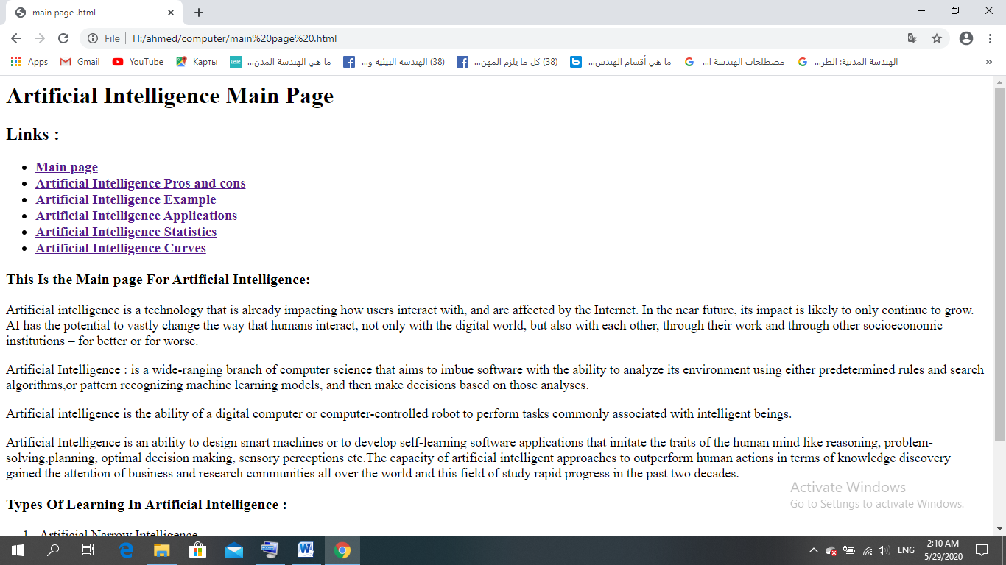**Screen shots**

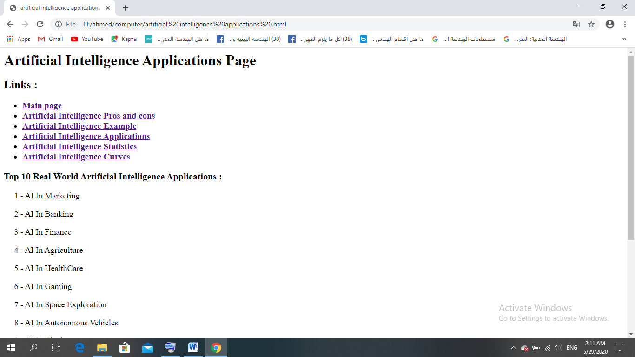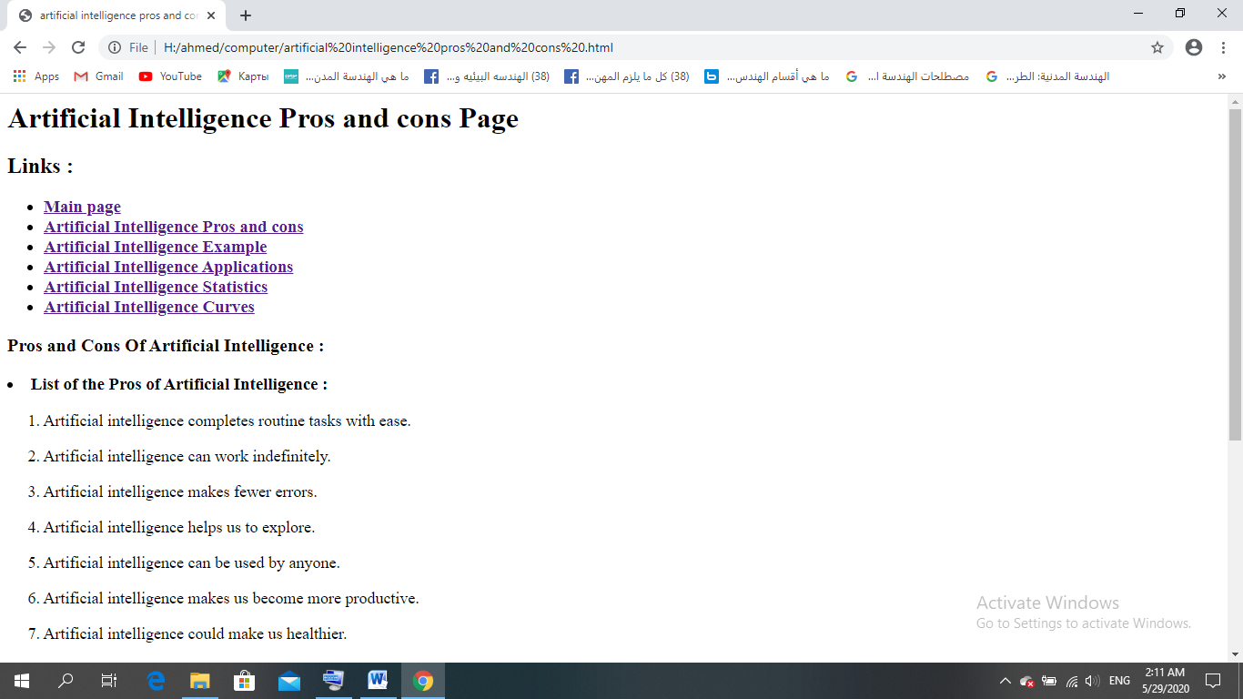



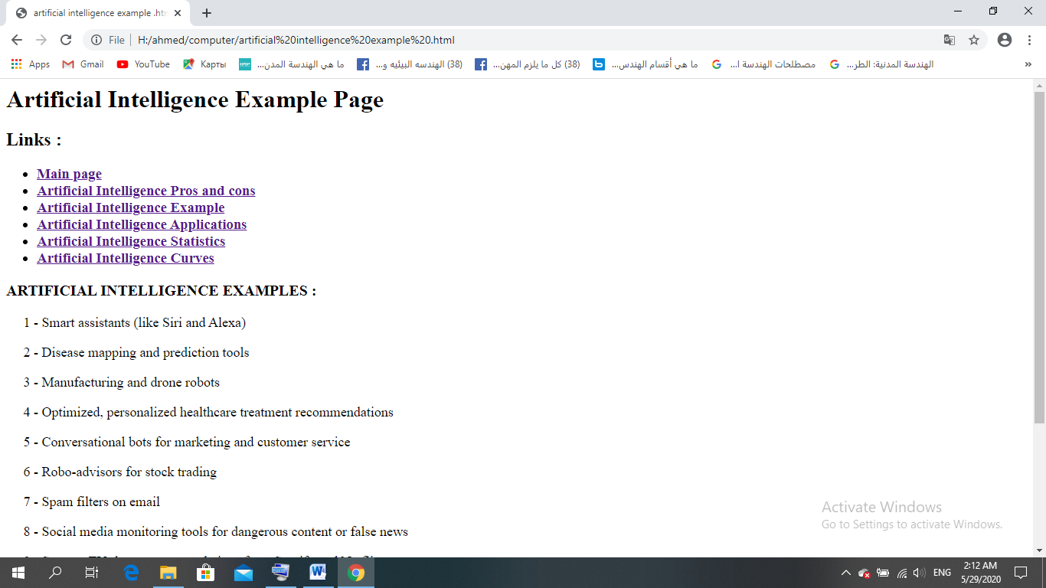

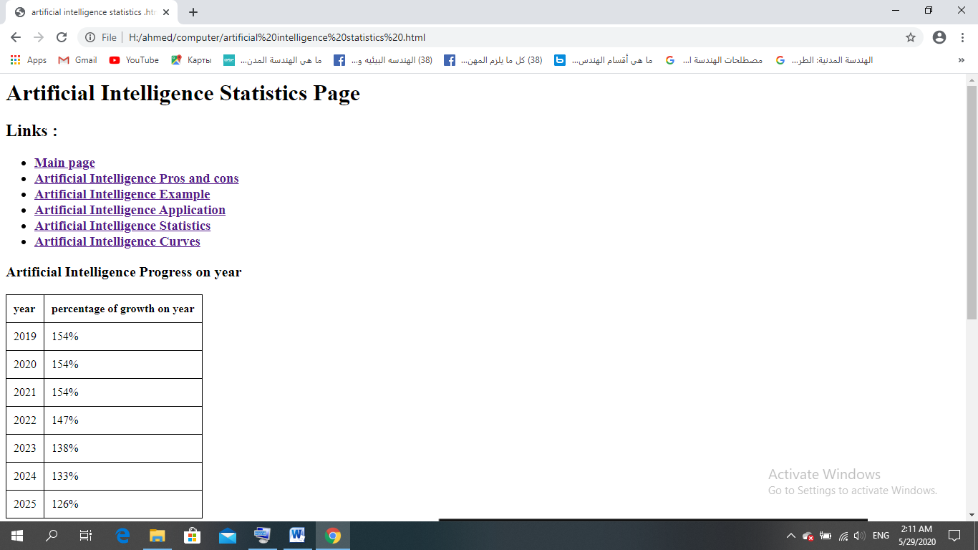

**Source code**

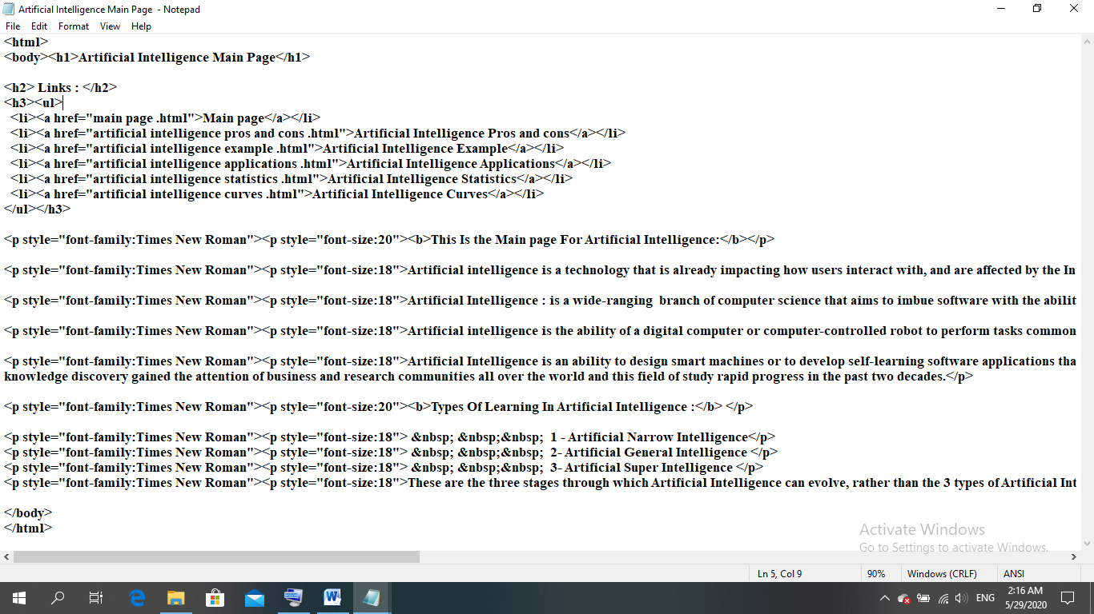

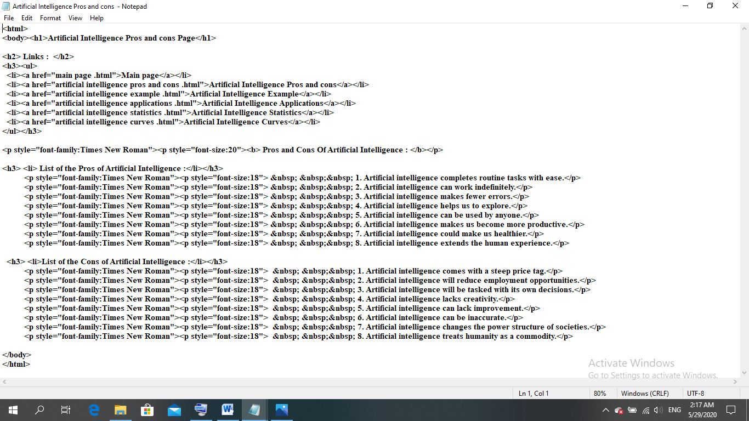

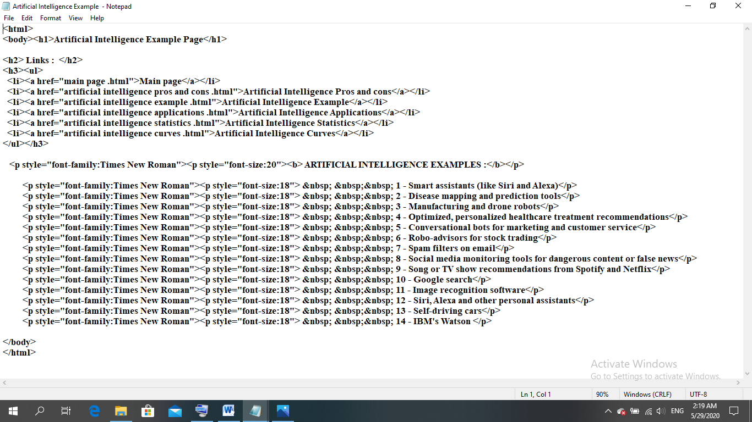

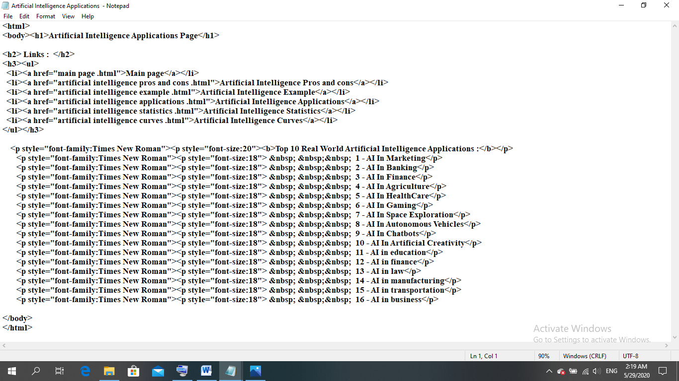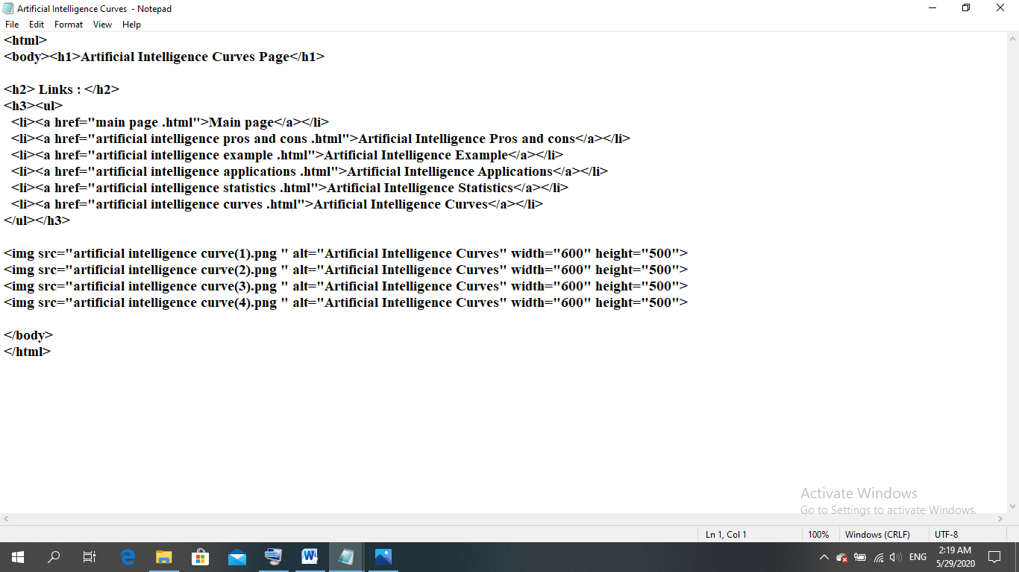

**References**

* The Egyptian Knowledge Bank, EKB.
* Artificial Intelligence Applications to Traffic Engineering BY M.BIELLI, G.AMBROSINO AND M.BOERO.
* Artificial Intelligence By Example: Develop machine intelligence from scratch using real artificial intelligence use cases ByDenis Rothman.
* Artificial Intelligence and the Future of Us: Imagination Not Knowledge Is King By FRANCES MAHAN.
* <https://waitbutwhy.com/2015/01/artificial-intelligence-revolution-1.html>
* <https://www.emarketer.com/content/artificial-intelligence-2018>
* <https://www.wegeek.co/artificial-intelligence/future-of-artificial-intelligence-and-its-political-impact/>
* <https://marketrealist.com/2016/11/nvidia-increase-adoption-artificial-intelligence-across-verticals/>